**Greta’s Haven Pet Rescue**

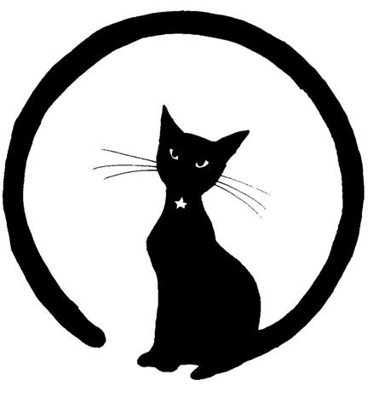

[www.gretashaven.com](http://www.gretashaven.com) • [gretashaven@gmail.com](mailto:gretashaven@gmail.com)

# Adoption Contract

The Adopter agrees to adopt the following animal (hereinafter called "Animal") from Greta’s Haven Pet Rescue:

|  |  |  |  |
| --- | --- | --- | --- |
| Name /ID |  | Species |  |
| Breed |  | Age |  |
| Markings |  | Sex |  |

As Adopter, I agree to the following:

1. To allow a representative of Greta’s Haven to visit my premises to insure the terms of this agreement have been kept;
2. The Animal will not be kept strictly outdoors; cats are adopted as indoor only pets.
3. The Animal will not be kept on a chain;
4. The Animal will be provided with adequate fresh food and water and daily exercise;
5. To provide a safe collar with rabies and I.D. tags as well as any locally required license tags to be worn at all times (as appropriate by species).
6. To obey all applicable laws governing control and custody of animals;
7. To provide all medical care and treatment needed by the Animal including but not limited to: yearly medical checkups and vaccines, and preventative heartworm medication;
8. The animal will not be de-clawed, tail docked, ear cropped or be subjected to any other unnecessary medical procedure;
9. To adopt the Animal only as a personal pet/companion and not as a gift, working animal, or guard dog;
10. The Animal is not to be sold or given away for any reason. If it becomes necessary to find the Animal another home, Greta’s Haven will be contacted and the Animal shall be returned to them;
11. I agree to pay an adoption fee of $_____. This fee is fully refundable during the four-week acclimation period. If after four weeks from the date of this contract the pet is returned to Greta’s Haven Pet Rescue, the adoption fee is forfeited.
12. I acknowledge that copies of the Animal’s medical records have been provided to me, that any ongoing medical issues have been explained and that I comprehend any medical and financial obligations that I, as the adopter, have to the Animal at the time of adoption.
13. I profess that I have researched the laws governing my community and that there are no statutes and / or laws that prevent me from legally owning this type or breed of animal.

Greta’s Haven Pet Rescue assumes no responsibility, nor shall they be held liable, for any damages caused by the adopted Animal to property, person or other pets. If any medical problems should occur after adoption, Greta’s Haven Pet Rescue is not liable for any medical bills.

As Adopter, I agree to accept full responsibility for the care of this animal releasing the previous owner as well as Greta’s Haven Pet Rescue and its representatives of any liability from this date forward.

I agree to abide by the adoption conditions and realize that I am committed to this animal for his/her life. I have read and fully understand that Greta’s Haven Pet Rescue may repossess this animal at any time if the adoption conditions are violated or the animal is mistreated.

 This adoption contract is entered into this ___ day of ___, 2010, between Greta’s Haven Pet Rescue and:

|  |  |  |  |  |  |
| --- | --- | --- | --- | --- | --- |
| Name |  | | | | |
| Address |  | | | | |
| Phone |  | Alternate |  | | |
| Fee |  | Method |  | | |
| Adopter |  | | | Date |  |
| Rescuer |  | | | Date |  |